**GitHub Desktop process to clone, update, commit and merge existing repository of ILms**

Steps to clone Git repository from Git to Local machine

1. Create one folder in local machine
2. Open GitHub desktop and click on File menu option
3. Click on clone repository

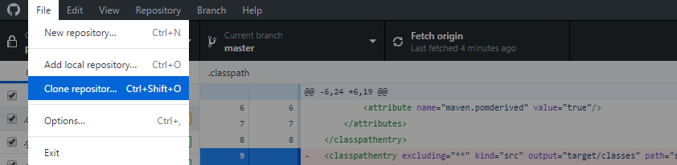

1. For first time it will ask GitHub credentials use your inspired eLearning GitHub repository credentials

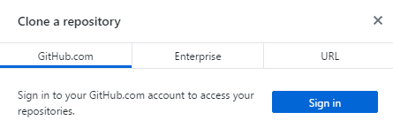

1. Click on Sign in link and enter credentials and then click sign in button

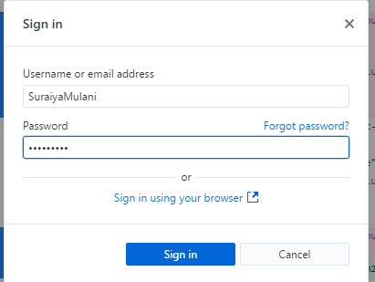

1. After sign in click on Clone repository. It will display all repositories accessible to you.

Select repository to be cloned in local machine.

Choose local path of folder location created in 1st step and click on **Clone** button.

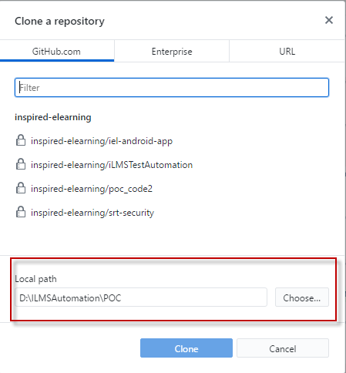

Once repository is cloned to local machine, we can create branches and start working on it.

**To create branch from cloned repository, follow below steps**

1. At the top of the GitHub desktop, switch to the branch that you want to base the new branch on by clicking the **Current Branch** and choosing required branch from the list.

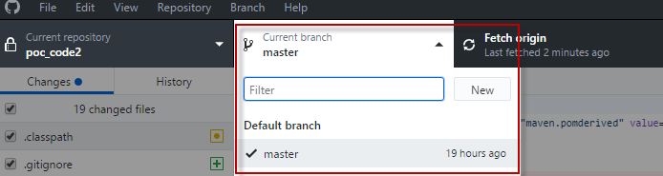

1. To create new branch, click on New button on current branch tab on GitHub desktop.

Enter branch name.

Select either the current branch, or the default branch (usually master) to base the new branch on.

click on Create branch button

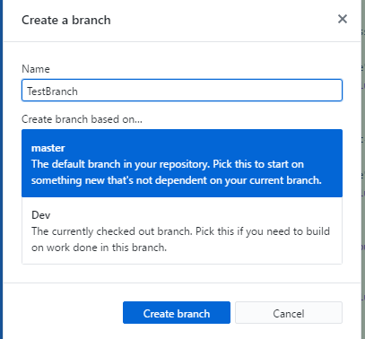

**To Import cloned project in Eclipse(Editor), follow below steps**

1. Open eclipse (editor) , Click on file menu and click on import option

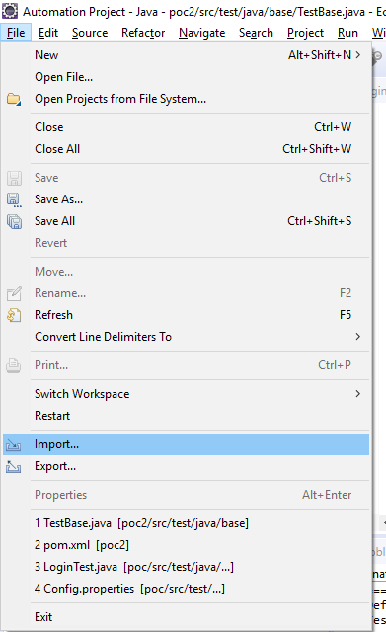

1. In import window select **Git** project
2. Select project from Git option and click on next button

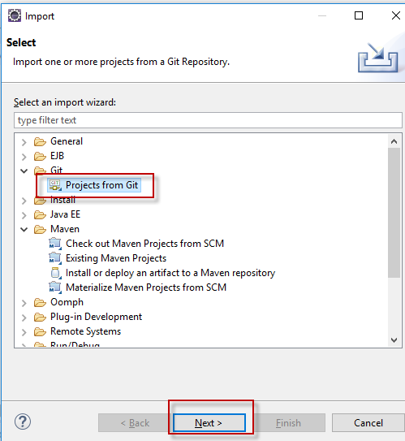

1. Select “**Existing local repository”** and click on Next

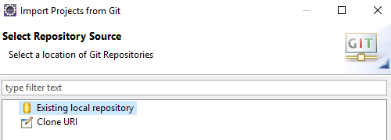

1. Select path of folder which is given in GitHub Desktop for mapping repository

It will display Git project in window. Click on next

1. Select Project root and click on Finish

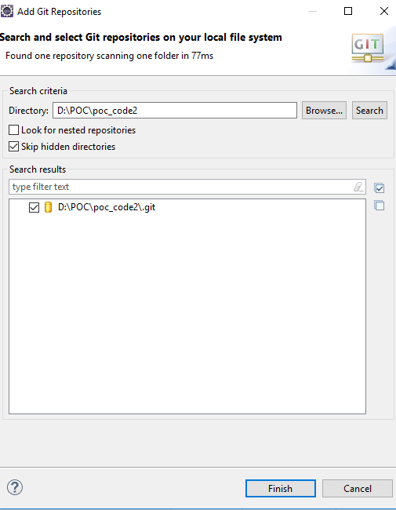

Once Project is imported in Eclipse it shows current branch name which we have selected while creating branch

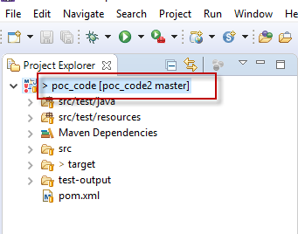

If we change branch in Git Desktop, it will get reflect in Eclipse also

**Or else we can directly change branch from eclipse by following below steps**

Right Click on project – select **Team** option and in that select **Switch To** menu it will display all branches for current repository (and also we can create new branch and switch to it from this menu). Select branch name on which we want to work.

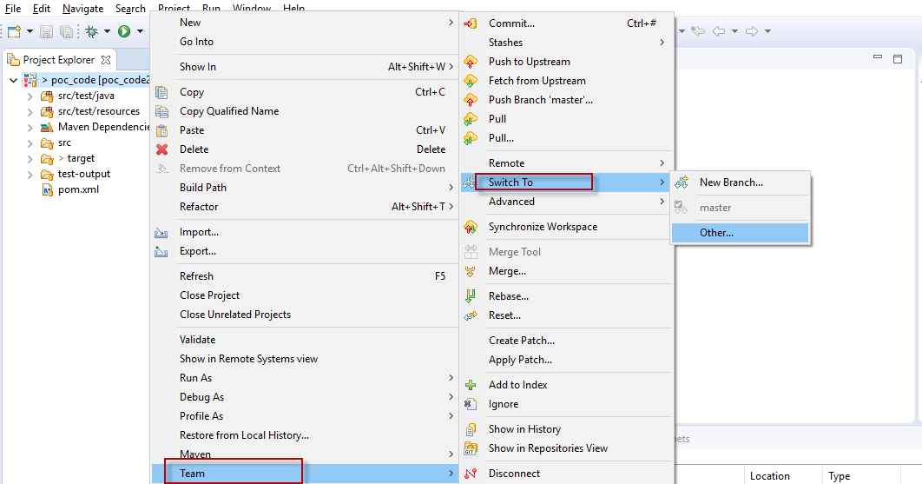

**Once you done with making changes/updates in branch we need to commit those changes and push it to GitHub branch**

As you make changes to files in your text editor and save them locally, you also see the changes in GitHub Desktop.

* The red icon indicates removed files.
* The yellow icon indicates modified files.
* The green icon indicates added files.
* To add all changes in all files to a **single commit**, keep the checkbox at the top of the list selected.

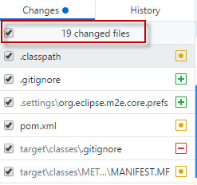

* To add all changes **in one or more files to a single commit**, deselect the files you don't want included, leaving only the files you want in the commit.

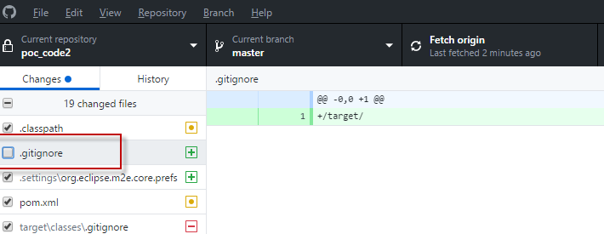

* Once you're satisfied with the changes you've chosen to include in your commit, write your commit message and push your changes.

At the bottom of the list of changes, in the Summary field, type a short, meaningful commit message. Optionally, you can add more information about the change in the Description field.

Under the Description field, click **Commit to *BRANCH*. (**In below screenshot Master is selected branch **)**

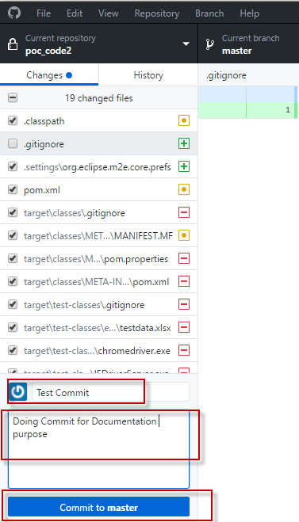

* When you're ready to push your commits to the remote repository, on the upper-right side of the toolbar, click **Push origin**.

